Exception Handling or Declarations

Exceptions

When an exceptional condition occurs in the course of a Java program, a special class called an Exception can be **thrown**, which indicates that something went wrong during the execution of the program. If the exception is not handled anywhere in the program, it will propagate up through the call stack until it is handled by the JVM which then terminates the program.

Exceptions Handling / Declaring Exceptions

When risky code is written that has the possibility of throwing an exception, it can be dealt with in one of two ways:

1. Handling means that the risky code is placed inside a try/catch block
2. Declaring means that the type of exception to be thrown is listed in the method signature with the throws keyword. This is also called "ducking" the exception - you let the code which calls the method deal with it.

### Exception Hierarchy

## Exception Class Hierarchy

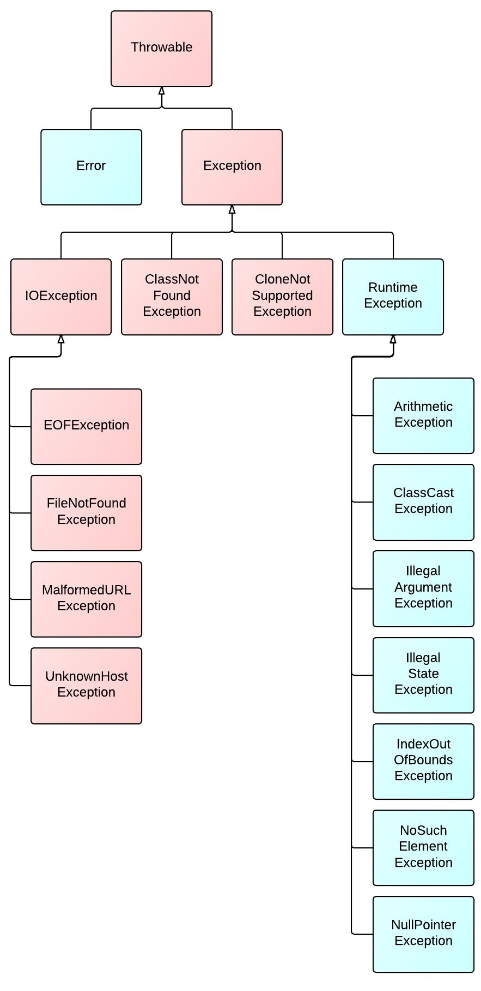

The exception class hierarchy starts with the Throwable class which inherits from Object. Any object which is a Throwable can be "thrown" in a program by the JVM or by the programmer using the throws keyword. The Exception and Error classes both extend Throwable. An Error represents something that went so horribly wrong with your application that you should not attempt to recover from. Some examples of errors are:

* ExceptionInInitializerError
* OutOfMemoryError
* StackOverflowError

Exception is a general exception class which provides an abstraction for all exceptions. There are many subclasses of Exception, as shown above.

## Unchecked vs. Checked Exceptions

The Exception class and all of its subclasses, except for RuntimeException, are known as "checked exceptions". These represent occasions where it is reasonable to anticipate an unexpected condition, like a file not existing when attempting to write to it (which would result in a FileNotFoundException). **Checked exceptions are required to be handled or declared by the programmer** - otherwise, the code will not compile.

RuntimeException is a special type of exception - it, and all of its subclasses - are known as "unchecked exceptions". An **unchecked exception** is an exception that **is not required to be handled or declared** like checked exceptions are. Some examples include:

* ArithmeticException for illegal math operations
* IndexOutOfBoundsException for if you reference an index that is greater than the length of an array
* NullPointerException for if you attempt to perform an operation on a reference variable that points to a null value

## Try-with-resources

When using try/catch blocks, often times some object used in the code is a resource that should be closed after it is no longer needed to prevent memory leaks - for example a FileReader, InputStream, or a JDBC Connection object. With Java 7, we can use a try-with-resources block which will automatically close the resource for us:

#### **Old way**

try {

InputStream is = new FileInputStream("./some/file.ext");

String s = is.read();

} catch(IOException e) {

} finally {

is.close();

}

#### **New way**

try(InputStream is = new FileInputStream("./some/file.ext")) {

String s = is.read();

} catch(IOException e) {}

Whatever is placed within the parenthesis of the try statement will be closed automatically - thus, we don't need to explicitly call it within our finally block above. This new format requires the object in the try statement to **implement the [AutoCloseable](https://docs.oracle.com/javase/8/docs/api/java/lang/AutoCloseable.html" \t "_blank) interface**.

### Multi-catch blocks

## Try/catch/finally Blocks

In order to handle exceptions that could be thrown in our application, a try/catch block can be used. The try block encloses the code that may throw an exception, and the catch block defines an exception to catch and then runs the code inside only if that type of exception is thrown. We can optionally include a finally block which will run whether an exception is thrown or not. A simple example is shown below:

try {

object.someRiskyMethodCall();

} catch(Exception e) {

System.out.println("phew! that was close!");

} finally {

System.out.println("I'll run whether there was a problem or not!");

}

### Try/catch/finally & Multi-catch Block Rules

Catch and finally blocks have several different rules which must be followed:

* Multiple catch blocks are allowed. More specific exceptions must come before more general exception types.
* Multi-catch blocks (catching more than one exception in a given block) are allowed, exception types are separated by ||
* The finally block is optional
* A try/finally block only IS allowed, but a try block by itself is not
* A finally block will always execute, unless of course System.exit() is called.

## Custom Exceptions

A programmer can create custom exceptions in Java by extending any exception class. If you extend RuntimeException, however, you will be creating an unchecked exception. This is a good idea if you do **not** want other code to have to handle your exception being thrown. If you do always want to require your exception to be handled, then create a checked exception by extending any existing one, or the Exception class itself.

public class MyCheckedException extends Exception {}

public class MyUncheckedException extends RuntimeException {}

public class ExceptionThrower {

public static void main(String[] args) {

try {

throw new MyCheckedException("uh oh");

} catch(MyCheckedException e) {} // we're just ignoring it here

if ( 100 > 1) {

throw new MyUncheckedException("you're not required to handle me!");

}

}

public static void declareChecked() throws MyCheckedException {

throw new MyCheckedException("this one is declared!");

}

}

### Collection API

## Collections Framework

The Collections framework in Java is a set of classes and interfaces that implement commonly used data structures. A collection is a single object which acts as a container for other objects. The Collections API is organized in a class hierarchy shown in simplified version below:

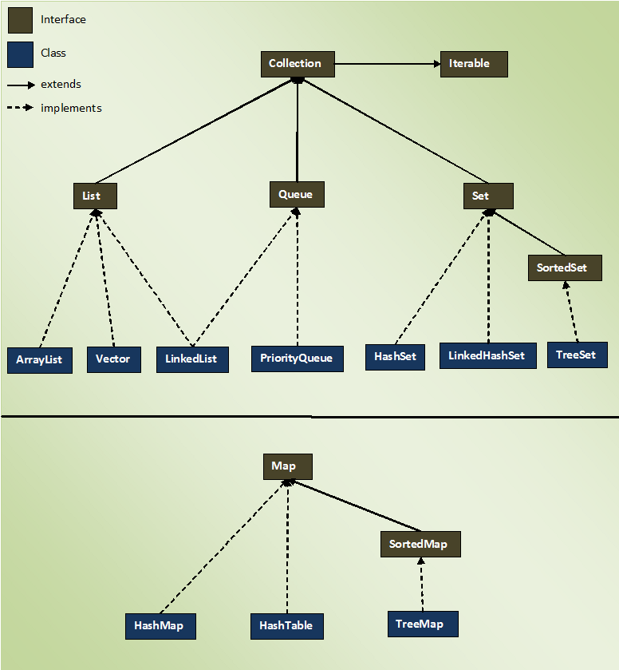

The important interfaces in the Collections API are:

* Iterable - guarantees the collection can be iterated over
* List - an ordered collection
* Set - a collection does not contain duplicates
* Queue - a collection that operates on a first-in-first-out (FIFO) basis
* Map - contains key/value pairs. Does not extend Iterable.

## Collections Class

The [Collections](https://docs.oracle.com/javase/8/docs/api/java/util/Collections.html) class - not to be confused with the Collection interface - defines many static helper methods which operate on any given collection. Use this class for help with sorting, searching, reversing, or performing other operations on collections.

### Lists

## List Interface

A List is a collection that is ordered and preserves the order in which elements are inserted into the list. Contrary to sets, duplicate entries are allowed. Also, elements are accessed by their index, which begins with 0 for the first element in the list.

### Vector

Vector is an older class which implements List - it is essentially a thread-safe implementation of an ArrayList.

### Stack

Stack is an older implementation of the stack data structure (last-in-first-out, or LIFO). Generally you should use an ArrayDeque for implementing a stack.

### Sets

## Set Interface

Set is an interface which defines a data structure which:

* is NOT index driven
* only allows unique elements
* generally DOES NOT preserve the order in which elements were inserted

### Queues

## Queue Interface

A Queue is a data structure used when elements should be added and removed in a specific order. Unless specified, elements are ordered FIFO (first-in-first-out). Some useful methods declared are:

* offer()
* peek()
* poll()

### Maps

## Map Interface

Map does not implement the Collection interface, however it is considered to be part of the Collections framework. It is used to identify a value by a key, and each entry in a map is a key-value pair. Because it does not implement Iterable, Maps cannot be iterated over directly. Instead, one must either:

* use the entrySet() method to iterate over the set of Map.Entry
* use the keySet() method to iterate over the set of keys
* use the values() method to return a Collection of values which can then be iterated over

### HashMap

HashMap is a Map which:

* Stores elements in key-value pairs
* Insertion/Retrieval of element by key is fast
* Tradeoff is that it does not maintain the order of insertion
* Permits one null key and null values

### TreeMap

TreeMap is a Map whose:

* Keys are stored in a Sorted Tree structure
* Main benefit is that keys are always in a sorted order
* Insertion/Retrieval are slow
* Cannot contain null keys as null cannot be compared for sorting

### HashTable

HashTable is an older, thread-safe implementation of a HashMap. It does not allow null keys or null values.

### HashSet and TreeSet

### HashSet

A HashSet implements Set and is backed by a HashMap. It:

* Guarantees no ordering when iterating
* Allows one null value
* Allows fast insertion and traversal
* Does not maintain order in which you insert elements

### TreeSet

A TreeSet is a Set whose elements maintain sorted order when inserted. Internally, it is backed by a Sorted Tree. Insertion and removal of elements is slow, because the elements must maintain sorted order. It cannot contain any null values, since null cannot be compared to any object.

### ArrayList and LinkedList

### ArrayList

An ArrayList is a concrete class which implements List. It is a data structure which contains an array within it, but can resize dynamically. Once it reaches maximum capacity, an ArrayList will increase its size by 50% by copying its elements to a new (internal) array. Traversal is fast (constant time) because elements can be randomly accessed via index, just like an array. Insertion or removal of elements is slow, however (linear time, since there is a risk of having to resize the underlying array).

### LinkedList

A LinkedList implements both the List and Queue interfaces, so it has all methods in both interfaces. The data structure is composed of nodes internally, each with a reference to the previous node and the next node - i.e. a doubly-linked list. Because of this structure, insertion or removal of elements is fast (no risk to resize, just change the nearest references), but traversal is slow for an arbitrary index.

### ArrayDeque and PriorityQueue

## ArrayDeque

Pronounced as 'array-deck', this concrete class can be implemented for either the queue or stack data structure. It is an implementation of a pure double-ended queue (elements can be added or removed from either end of the queue). An ArrayDeque stores elements in a resizable array internally, and it has a few extra useful methods defined:

* pop()
* push()
* peekFirst()
* peekLast()
* pollFirst()
* pollLast()
* offerFirst()
* offerLast()

| **Operation** | **Throws Exception** | **Returns null** |
| --- | --- | --- |
| Insert | boolean add(E e) | boolean offer(E e) |
| Remove | E remove() | E poll() |
| Examine | E element() | E peek() |

## PriorityQueue

We know that Queue serves the requests based on FIFO(First in First out) but sometimes the elements of the queue are needed to be processed according to the priority, that’s when the PriorityQueue comes into a picture.

A PriorityQueue serves the requests based on the priority heap. The elements of the priority queue are ordered according to their natural ordering, or by a Comparator provided at queue construction time, depending on which constructor is used. A priority queue does not permit null elements. A priority queue relying on natural ordering also does not permit insertion of non-comparable objects (doing so may result in ClassCastException).

### Methods of PriorityQueue Class

* boolean add(E e) - Inserts the specified element into this priority queue.
* void clear() - Removes all of the elements from this priority queue.
* Comparator<? super E> comparator() - Returns the comparator used to order the elements in this queue, or null if this queue is sorted according to the natural ordering of its elements.
* boolean contains(Object o) -Returns true if this queue contains the specified element.
* Iterator<E> iterator() -Returns an iterator over the elements in this queue.
* boolean offer(E e) -Inserts the specified element into this priority queue.
* E peek() -Retrieves, but does not remove, the head of this queue, or returns null if this queue is empty.
* E poll() -Retrieves and removes the head of this queue, or returns null if this queue is empty.
* boolean remove(Object o) -Removes a single instance of the specified element from this queue, if it is present.
* int size() -Returns the number of elements in this collection.
* Object[] toArray() -Returns an array containing all of the elements in this queue.
* <T> T[] toArray(T[] a) -Returns an array containing all of the elements in this queue; the runtime type of the returned array is that of the specified array.

## Comparable Interface

[Comparable](https://docs.oracle.com/javase/8/docs/api/java/lang/Comparable.html) is an interface which defines the natural ordering for a class. A class must implement Comparable if it is to be sorted by the compareTo() method.

public interface Comparable<T> {

public int compareTo(T o);

}

The compareTo() method returns an int which is:

* Zero, if the two objects are equal
* Negative, if this object is smaller than that
* Positive, if this object is greater than that

## Comparator Interface

[Comparator](https://docs.oracle.com/javase/8/docs/api/java/util/Comparator.html) is an interface which allows you to define a total ordering on some collection of objects. A class that is to be sorted by compare() does not have to implement Comparator.

public interface Comparator<T> {

public int compare(T firstObject, T secondObject);

}

## Generics

Generics are constructs introduced in Java 5 which enforce compile time safety by allowing you to use parameterized types. They are covered here because they are frequently and heavily used with collections. Generics can be declared on a class (generic types), method parameters (generic methods), or return types.

Before Java 5, you had to write something like this and hope other developers understood to only put Strings inside:

List names = new ArrayList();

names.add("Alice"); // good use

name.add(new Object()); // uh oh - we want to prevent this from happening

With generics, you can restrict a class to only accept objects of a given type and the compiler will prevent you from using any other type:

List<String> names = new ArrayList<>(); // using a List of Strings only

names.add("Alice"); // nice!

names.add(new Object()); // now we get a compilation error to stop this - generics save the day!

### Generic Classes

To make a class (or interface) generic, use the angle brackets when declaring it, and use an arbitrary "generic type" which is determined by the invoking code. The generic type can then be reused throughout the class to enforce type safety.

public class MyGenericClass<T> {

private T instance;

// simple generic setter method

public void setObject(T object) {

this.instance = object;

}

}

### Naming Convention for Generics

Technically, type parameters can be named anything you want. The convention is to use single, uppercase letters to make it obvious that they are not real class names.

* E => Element
* K => Map Key
* V => Map Value
* N => Number
* T => Generic data type
* S, U, V, and so on => For multiple generic data types